Assessment Schedule – 2014

Chemistry: Demonstrate understanding of bonding, structure, properties and energy changes (91164)

Evidence Statement
Q | Evidence | Achievement | Achievement with Merit | Achievement with Excellence
ONE  (a) | Lewis structures shown (see Appendix One). | - Two Lewis structures correct.
(b) (i)  (ii) | The bond angle x is approx. 120° and bond angle y is approx. 109.5°.  The B atom has three regions of electron density around it. These are all bonding regions. The regions of electron density are arranged to minimise repulsion / are arranged as far apart as possible from each other. (This is why the bond angle is 120°.)  The O atom has four regions of electron density around it. The regions of electron density are arranged to minimise repulsion / are arranged as far apart as possible from each other in a tetrahedral arrangement / two of these are bonding (and two are non-bonding). This is why the bond angle is 109.5°. | - One bond angle correct.  - States the number of regions of electron density around the B atom or the O atom. | - For ONE atom, the (stated) number of regions of electron density are arranged to minimise repulsion / are arranged as far as possible linked to the bond angle. | - The arrangement of the electron density around the central atoms is used to justify the shapes and bond angles for both molecules.
(c) | SO₂ molecule is polar.  CO₂ molecule is non-polar.  The S–O / S=O bond is polar due to the difference in electronegativity between S and O atoms. The bonds are arranged asymmetrically in a bent shape around the central S atom; therefore the (bond) dipoles do not cancel and the molecule is polar.  The C=O bond is polar due to the difference in electronegativity between C and O atoms. The bonds are arranged symmetrically in a linear shape around the central C atom; therefore the (bond) dipoles cancel and the molecule is non-polar. | - One bond correctly identified as being polar.  OR  Atoms have different electronegativities. | - Explains polar bonds is due to the difference in electronegativity between  S and O (atoms) or  C and O (atoms).  OR  Bond dipoles cancelling or not cancelling linked to the overall molecule polarity of either SO₂ or CO₂ molecule. | - The polarity of both molecules is justified with reference to the polarity of the bonds, the shape and the polarity of the molecule.
(d) | ∆_{r}Hº  = ∑(bonds broken) – ∑(bonds formed)  Bonds broken  H–H = 436  ½ × O=O = ½ × 498  Total = 685 kJ mol^{–1}  Bonds formed  2 × O–H  ∑(bonds formed)  = ∑(bonds broken) – ∆_{r}Hº  = 685 – (– 242)  = 927 kJ mol^{–1}  2 × O–H = 927 kJ mol^{–1}  O–H = 464 (463.5) kJ mol^{–1} | - Identifies bonds broken and bonds formed.  - Bonds broken = 685 kJ mol^{–1}. | - Correct process for calculating bond enthalpy, with one error. | - Correctly calculates the bond enthalpy of O–H.

NØ | N1 | N2 | A3 | A4 | M5 | M6 | E7 | E8
No response or no relevant evidence. | 1a | 2a | 3a | 4a | 2m | 3m | 2e | 3e

Appendix One: Question One (a)

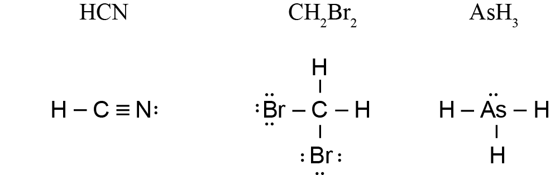

Q | Evidence | Achievement | Achievement with Merit | Achievement with Excellence
TWO  (a) |  | - ONE row or one column correct.
  Type of substance | Type of particle | Attractive forces between particles
  Metallic | Atoms / cations and electrons | Metallic bonds / electrostatic attraction between positive ion (cation) and electron
  Molecular | Molecules | Intermolecular forces
(b) | Graphene has strong covalent bonds. Because the covalent bonds are strong / there are a large number of covalent bonds, it requires a lot of energy to break these bonds, and therefore the melting point is high.  Each carbon atom is bonded to only three other carbon atoms. Therefore each carbon atom has free / delocalised /valence electron(s), to conduct electricity. | - Graphene has strong covalent bonds.  - Graphene has delocalised electron(s). | - Explains why graphene has ahigh melting point OR conducts electricity, linked to structure and bonding. | - Justifies both properties of graphene in terms of structure and bonding.
(c) | Magnesium atoms are held together in a 3–D lattice by metallic bonding in which valence electrons are attracted to the nuclei of neighbouring atoms.  Iodine molecules are held together by weak intermolecular forces.  Ductility  The attraction of the Mg atoms for the valence electrons is not in any particular direction; therefore Mg atoms can move past one another without disrupting the metallic bonding, therefore Mg is ductile.  The attractions between iodine molecules are directional. If pressure is applied the repulsion between like-charged ions will break the solid, therefore I₂ is not ductile.  Dissolving in cyclohexane  Magnesium does not dissolve in cyclohexane because cyclohexane molecules are not attracted to the magnesium atoms in the metallic lattice.  Iodine is soluble, as iodine is a non-polar molecule. The iodine molecules and cyclohexane molecules form weak intermolecular attractions.  Electrical conductivity  Valence electrons of Mg atoms are free to move throughout the structure. This means that magnesium can conduct electricity.  Iodine does not conduct electricity as it does not contain delocalised electrons. | - For magnesium OR iodine, reason for ductility given.  - For magnesium OR iodine, reason for solubility given.  - For magnesium OR iodine, reason for electrical conductivity given. | - Links structure and bonding in magnesium to TWO of its properties.  - Links structure and bonding in iodine to TWO of its properties. | - Explains properties of magnesium by linking structure and bonding to all three properties.  - Explains properties of iodine by linking structure and bonding to all three properties.

NØ | N1 | N2 | A3 | A4 | M5 | M6 | E7 | E8
No response or no relevant evidence. | 1a | 2a | 3a | 4a | 2m | 3m | 2e | 3e

Q | Evidence | Achievement | Achievement with Merit | Achievement with Excellence
THREE  (a)(i)  (ii) | Exothermic, as the temperature increases, which shows energy is being released.  Exothermic, weak intermolecular attractions form between the water molecules, this releases energy. | - Exothermic because energy is being released.  - Exothermic because bonds are being formed, releasing energy.
(b) | Solubility  When sodium chloride is dissolved in water the attractions between the polar water molecules and between the ions in the salt are replaced by attractions between the water molecules and the ions. The negative charges on the oxygen ends of the water molecules are attracted to the positive Na⁺ ions, and the positive hydrogen ends of the water molecules are attracted to the negative Cl– ions.  See Appendix Two for an example of annotated diagram. | - NaCl is ionic /  Na⁺ and Cl–  - H₂O with δ+ and δ –. | - Explains the attractions between water molecules and the ions. | - Solubility of NaCl explained, supported by annotated diagram.
(c) | n(CH₃OH) = m / M = 345 / 32 = 10.78 mol  n(C₂H₅OH) = m / M = 345 / 46 = 7.50 mol  2 mol CH₃OH release 1 450 kJ of energy  1 mol CH₃OH releases 725 kJ of energy  10.78 mol CH₃OH releases 725 kJ × 10.78  = 7 816 kJ of energy  1 mol C₂H₅OH releases 1 370 kJ of energy  7.5 mol C₂H₅OH releases 1 370 kJ × 7.5 = 10 275 kJ of energy  Therefore C₂H₅OH releases more energy when 345 g of fuel are combusted. | - Amount of CH₃OH or C₂H₅OH correct.  - Energy released for one mol CH₃OH or C₂H₅OH correct. | - TWO steps of calculation correct for both CH₃OH and C₂H₅OH, with conclusion. | - Justifies choice of fuel with correct calculations and unit.

NØ | N1 | N2 | A3 | A4 | M5 | M6 | E7 | E8
No response or no relevant evidence. | 1a | 2a | 3a | 4a | 2m with one error in  (b) or (c) | 2m | 2e with one error in  (b) or (c) | 2e

Appendix Two: Question Three (b)

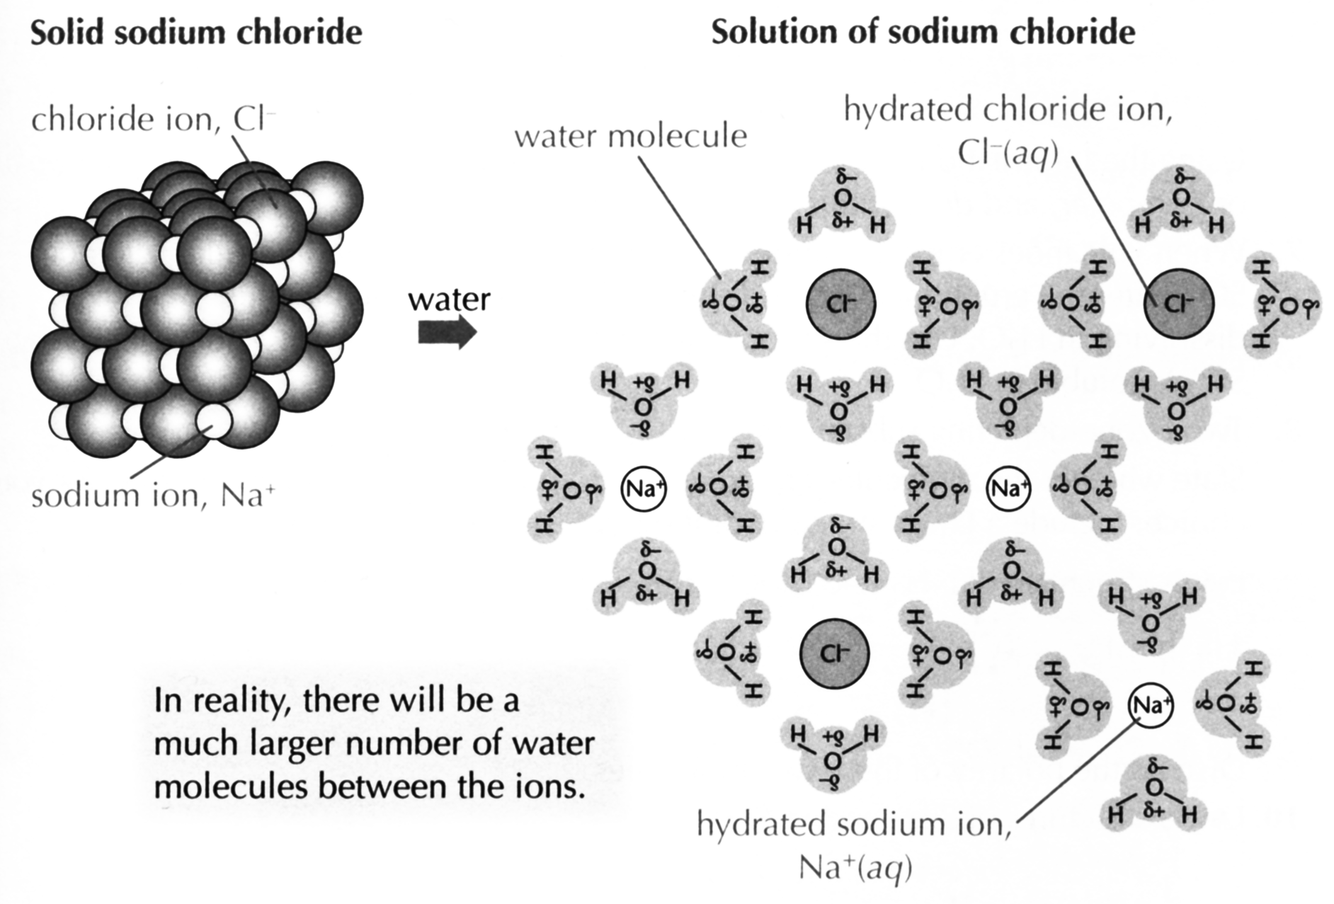

Suzanne Boniface, ESA Study Guide Level 2 Chemistry, page 115 (Auckland: ESA Publications (NZ) Ltd, 2012), p 115.

Cut Scores
 | Not Achieved | Achievement | Achievement with Merit | Achievement with Excellence
Score range | 0 – 7 | 8 – 13 | 14 – 18 | 19 – 24

